**SALES AND PROFIT DASHBOARD**

**1 Define Key Metrics**: Identify the key sales and profit metrics want to track. This could include total sales, net profit, gross profit margin, sales growth rate, etc.

2 **Select a Dashboard Tool**: I Have chosen Microsoft Power BI to make this Dashboard.

3 **Data Collection and Integration**: Collect data from sales and financial systems. Integrate data sources into your dashboard tool to ensure real-time or regular updates.

4 **Design Layout**: Design the layout of dashboard. Organize it in a clear and intuitive way so users can quickly understand the information presented. Typically, have sections for sales trends, profit trends, and key performance indicators (KPIs).

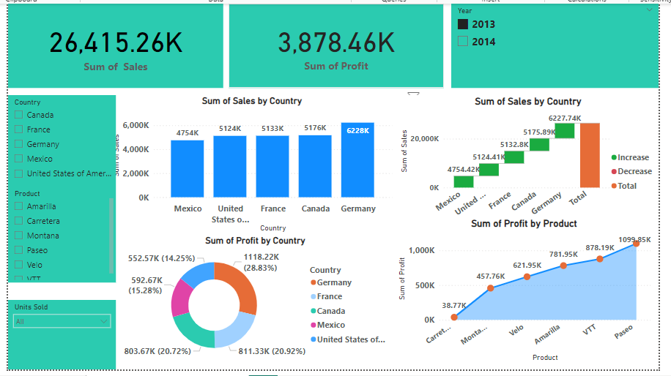

**5 Sales Trends:** Display sales trends over time using Pie Chart, area chart or bar charts. You can break it down by product, Country, Year or sales channels.

6 **Profit Trends:** Show profit trends alongside sales trends. This could include gross profit margin and net profit margin over time. Highlight any significant fluctuations or trends.

7 **Filters and Drill-downs**: Incorporate filters and drill-down capabilities to allow users to explore data at a more granular level. For example, users should be able to filter by date range, product category, or geographic region.

**8 Conclusion:** By looking this Dashboard we can easily say that United states of America has more sales and France has more profit by sum of sales and sum of profit. And also, Paseo product is more profit and Carretera is less profit.